Task on RDS. Database
Create mariadb db on ec2.
[ec2-user@ip-172-31-3-132 ~]$ sudo su -
[root@ip-172-31-3-132 ~]# yum -y install mariadb-server wget
[root@ip-172-31-3-132 ~]# systemctl enable mariadb
Created symlink from /etc/systemd/system/multi-user.target.wants/mariadb.service to /usr/lib/systemd/system/mariadb.service.
[root@ip-172-31-3-132 ~]# systemctl start mariadb
[root@ip-172-31-3-132 ~]# yum -y update
Loaded plugins: extras_suggestions, langpacks, priorities, update-motd
No packages marked for update
[root@ip-172-31-3-132 ~]# DBName=ec2db
[root@ip-172-31-3-132 ~]# DBPassword=kazmi2452
[root@ip-172-31-3-132 ~]# DBRootPassword=kazmi2452
[root@ip-172-31-3-132 ~]# DBUser=ec2dbuser
[root@ip-172-31-3-132 ~]# echo "CREATE DATABASE ${DBName};">> /tmp/db.setup
[root@ip-172-31-3-132 ~]# echo "CREATE USER '${DBUser}' IDENTIFIED BY '${DBPassword}';">> /tmp/db.setup
[root@ip-172-31-3-132 ~]# echo "GRANT ALL PRIVILEGES ON *.* TO '${DBUser}'@'%';">> /tmp/db.setup
[root@ip-172-31-3-132 ~]# echo "FLUSH PRIVILEGES;">> /tmp/db.setup
[root@ip-172-31-3-132 ~]# mysqladmin -u root password "${DBRootPassword}"
[root@ip-172-31-3-132 ~]# mysql -u root --password="${DBRootPassword}"< /tmp/db.setup
[root@ip-172-31-3-132 ~]# rm /tmp/db.setup
rm: remove regular file ‘/tmp/db.setup’?
[root@ip-172-31-3-132 ~]# mysql -u root --password="${DBRootPassword}"
Welcome to the MariaDB monitor. Commands end with ; or \g.
Your MariaDB connection id is 4
Server version: 5.5.68-MariaDB MariaDB Server
Copyright (c) 2000, 2018, Oracle, MariaDB Corporation Ab and others.
Type 'help;' or '\h' for help. Type '\c' to clear the current input statement.
MariaDB [(none)]>

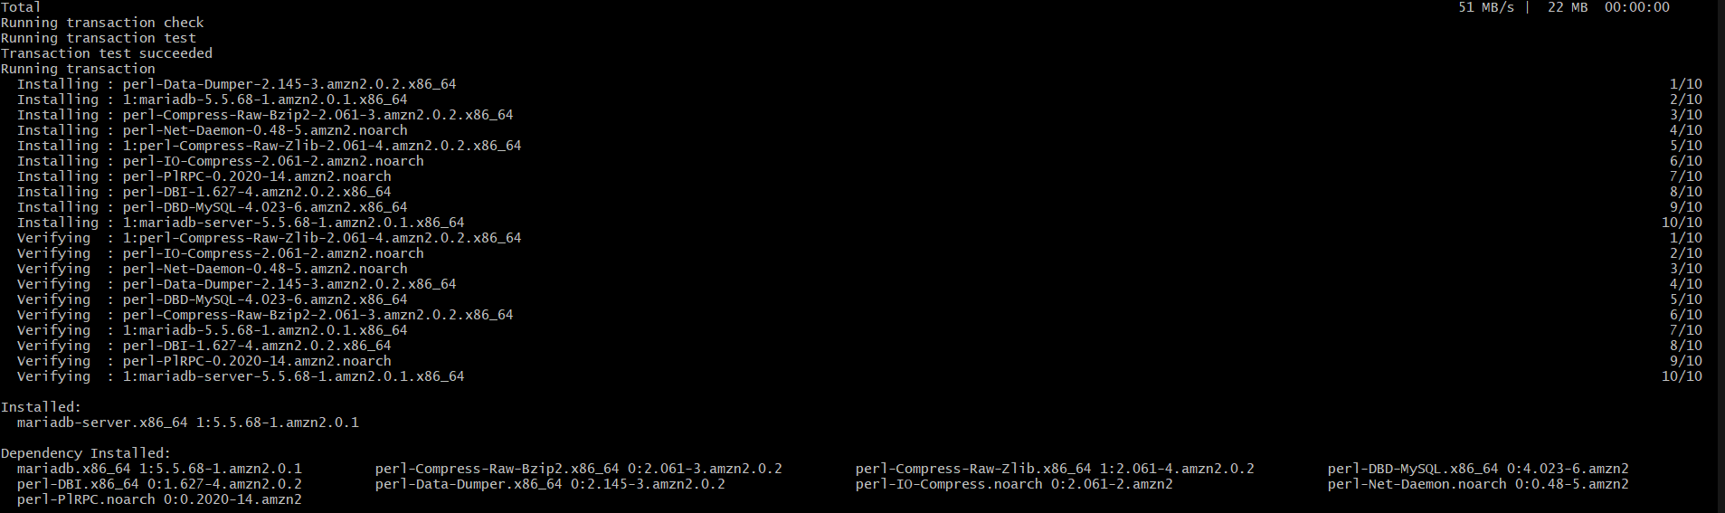

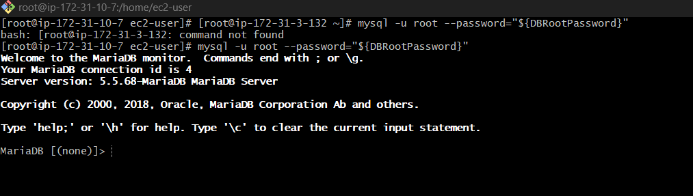

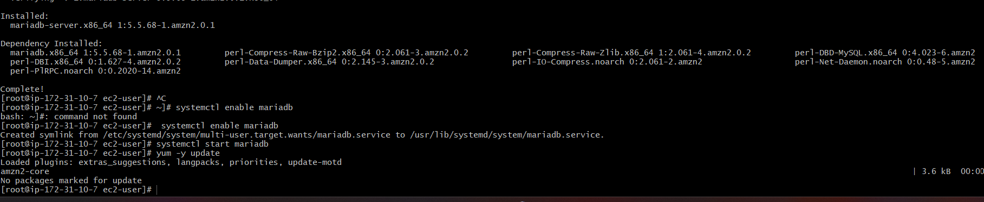
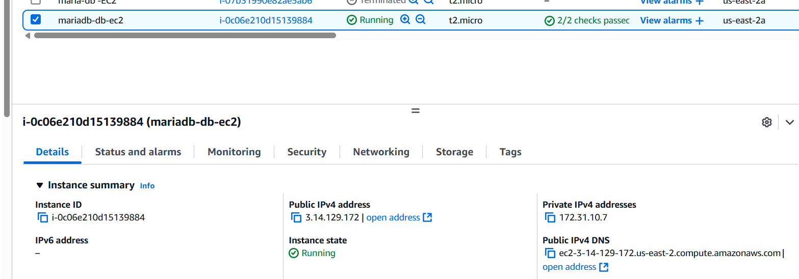

2) Insert some dummy data
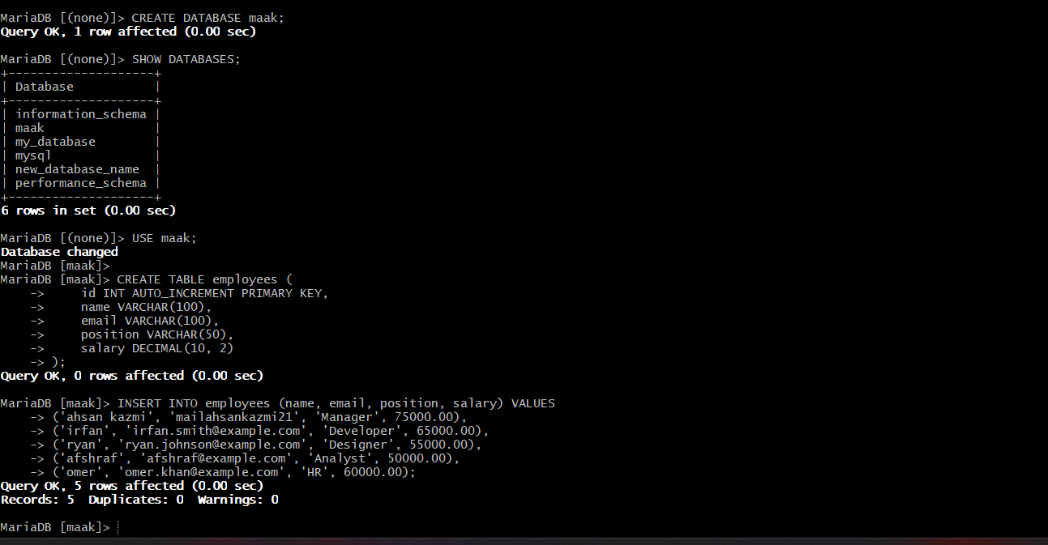

SELECT * FROM employees; employees I the table name

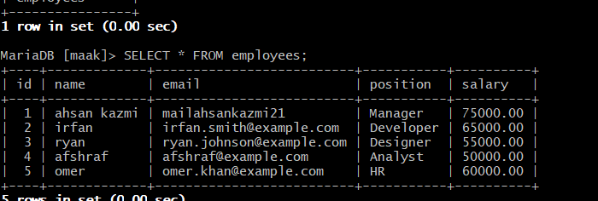

3) Take the backup of dummy data on ec2
[root@ip-172-31-3-132 ~]# mysqldump -u root -p ec2db > vijaya.sql
Enter password:
[root@ip-172-31-3-132 ~]# ls
Ahsan.sql

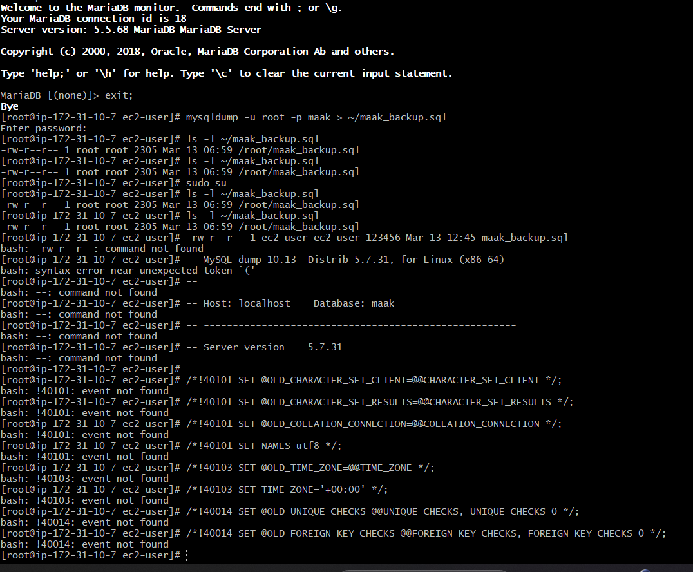

4) launch Mariadb RDS instance.
database ec2 login credentials

ec2 name: databasemaak1
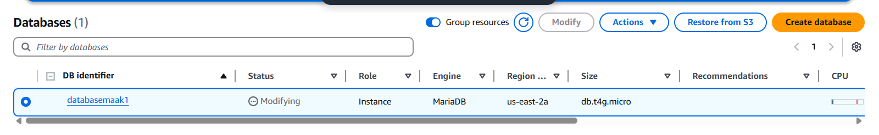

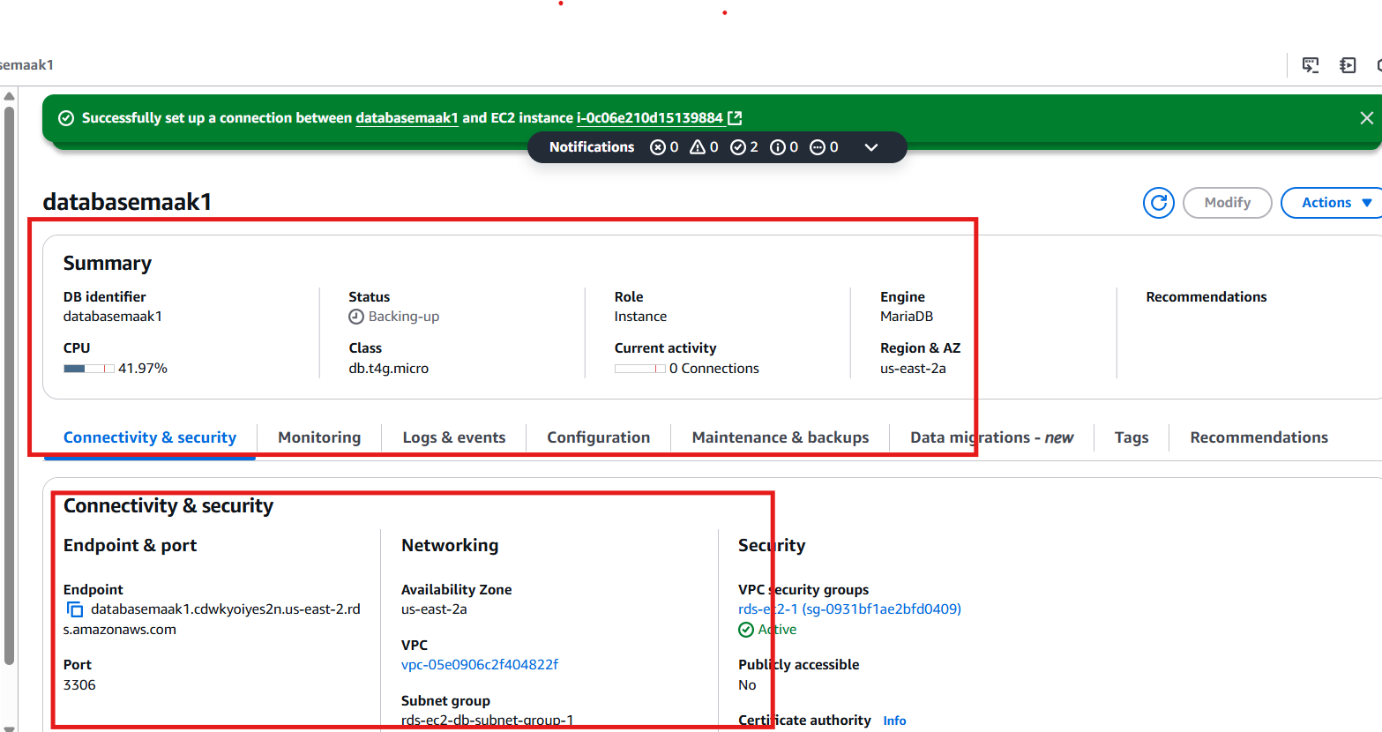

5) Migrate database from ec2 to RDS.
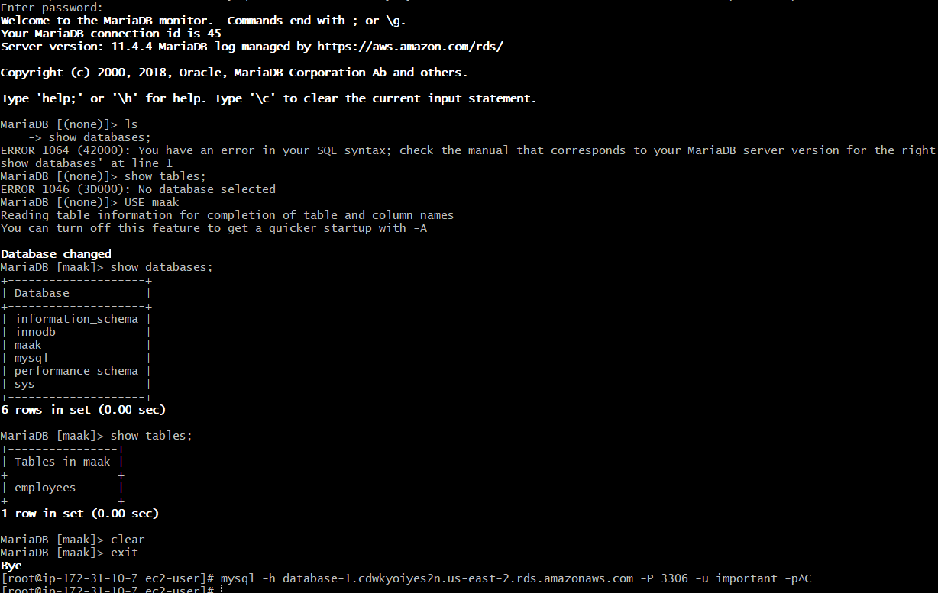
mysql -h databasemaak1.cdwkyoiyes2n.us-east-2.rds.amazonaws.com -P 3306 -u your-username -p

mysql -h database-1.cdwkyoiyes2n.us-east-2.rds.amazonaws.com -P 3306 -u important -p maak < ~/maak_backup.sql
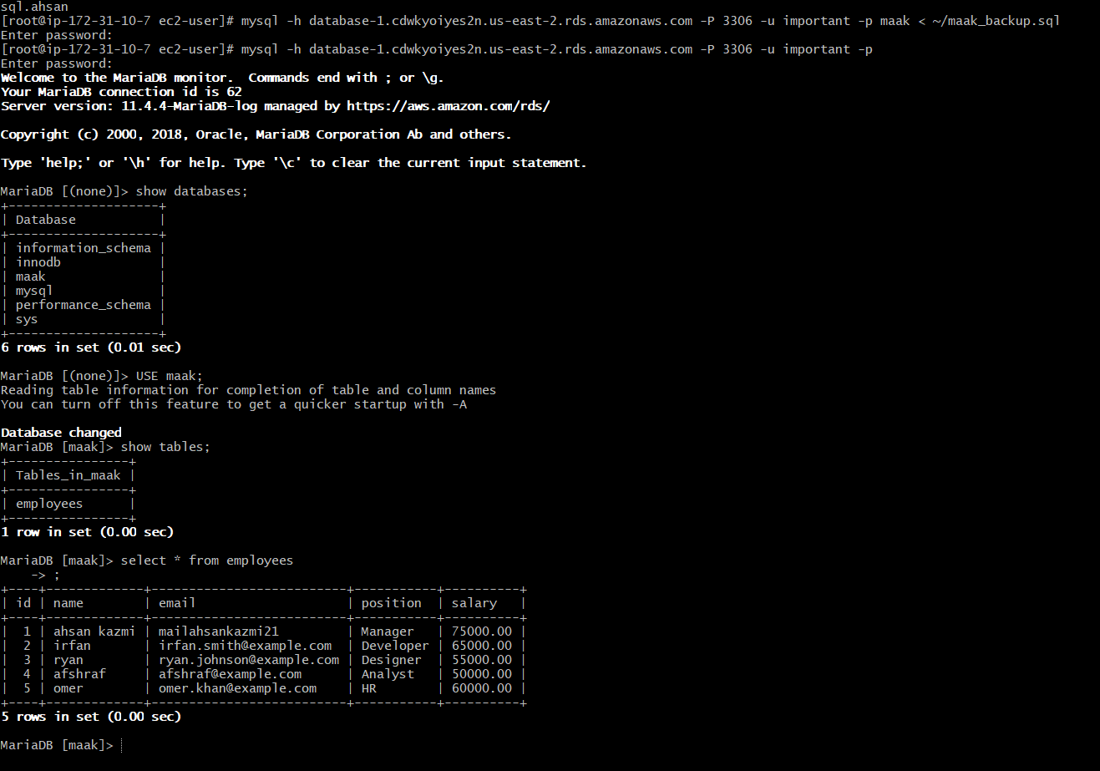

6) Install mysql db on ec2

yum install https://dev.mysql.com/get/mysql80-community-release-el7-5.noarch.rpm

yum install mysql-community-server

Step 1: successfully installed the MySQL Community repository! Now, let's proceed with the installation of MySQL Server

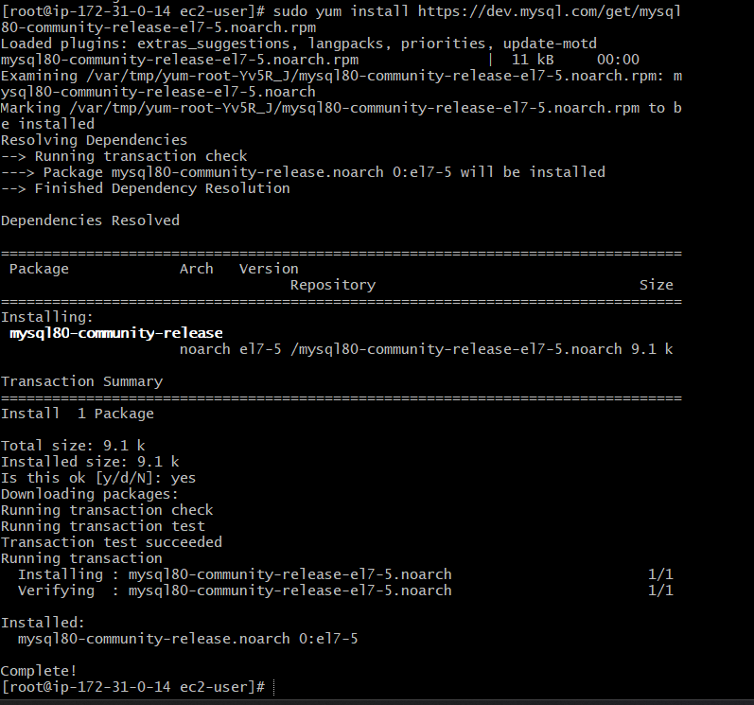
Correct steps to install mysql server refer from other person
sudo rpm –Uvh https://repo.mysql.com/mysql80-community-release-el7.rpm
sudo yum install -y mysql-community-server
sudosystemctl start mysqld
sudosystemctl enable mysqld
sudosystemctl status mysqld

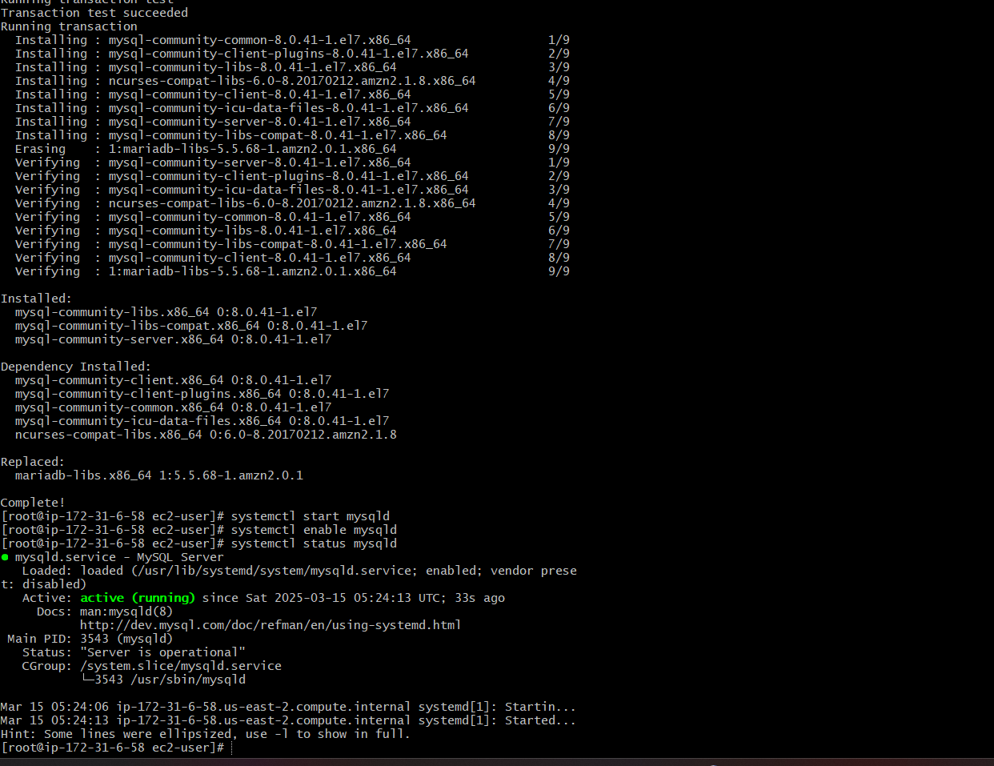

7) Launch mysql RDS image
Click on create database:
Engine options: mysql
Engine version: latest version
Template: freetier
DB instance identifier: mysqldb
Credentials settings:
Master username: admin
Click on self managed password
Master password: admin123456
Instance configuration: db.t3.micro
Storage: disable auto scaling
Connectivity: don’t connect to ec2
Network type: IPV4
VPC: default
Public access: yes
Security group: existing : default
AZ: us-east-1a
Database authentication: PW authentication
Monitoring: standard
Click on create database
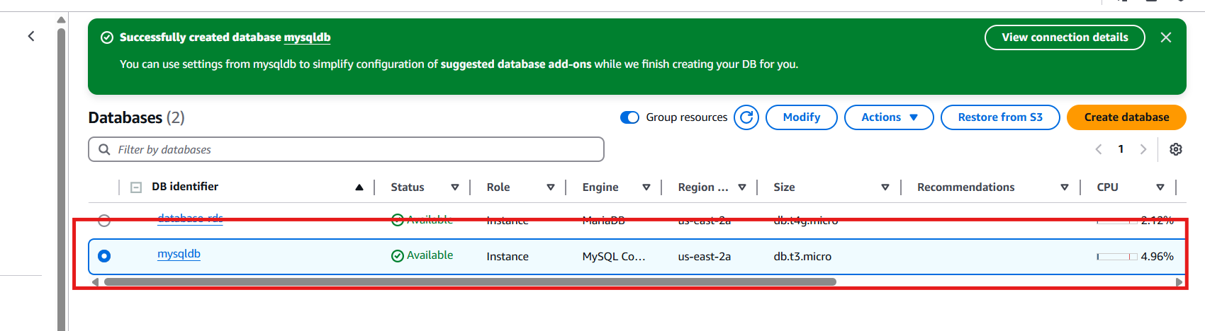
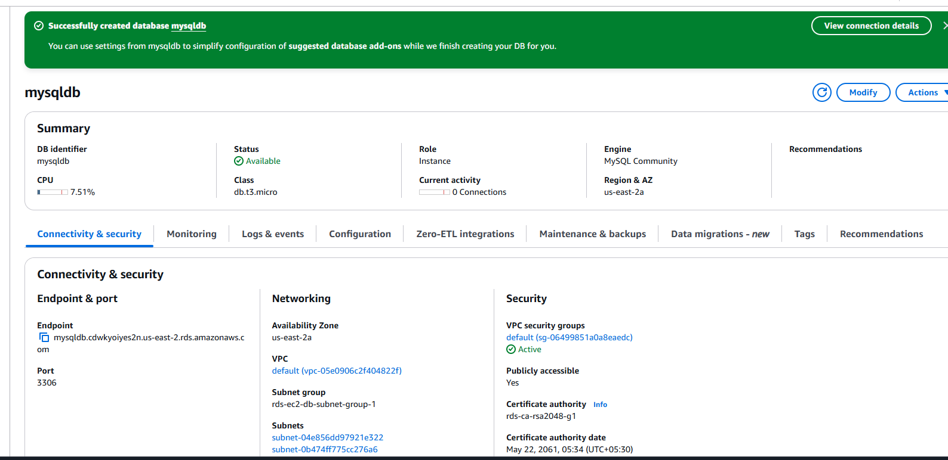
8) COnfigure multi AZ

Click on actions - Click on convert multi availability zone
Click on apply-immediately

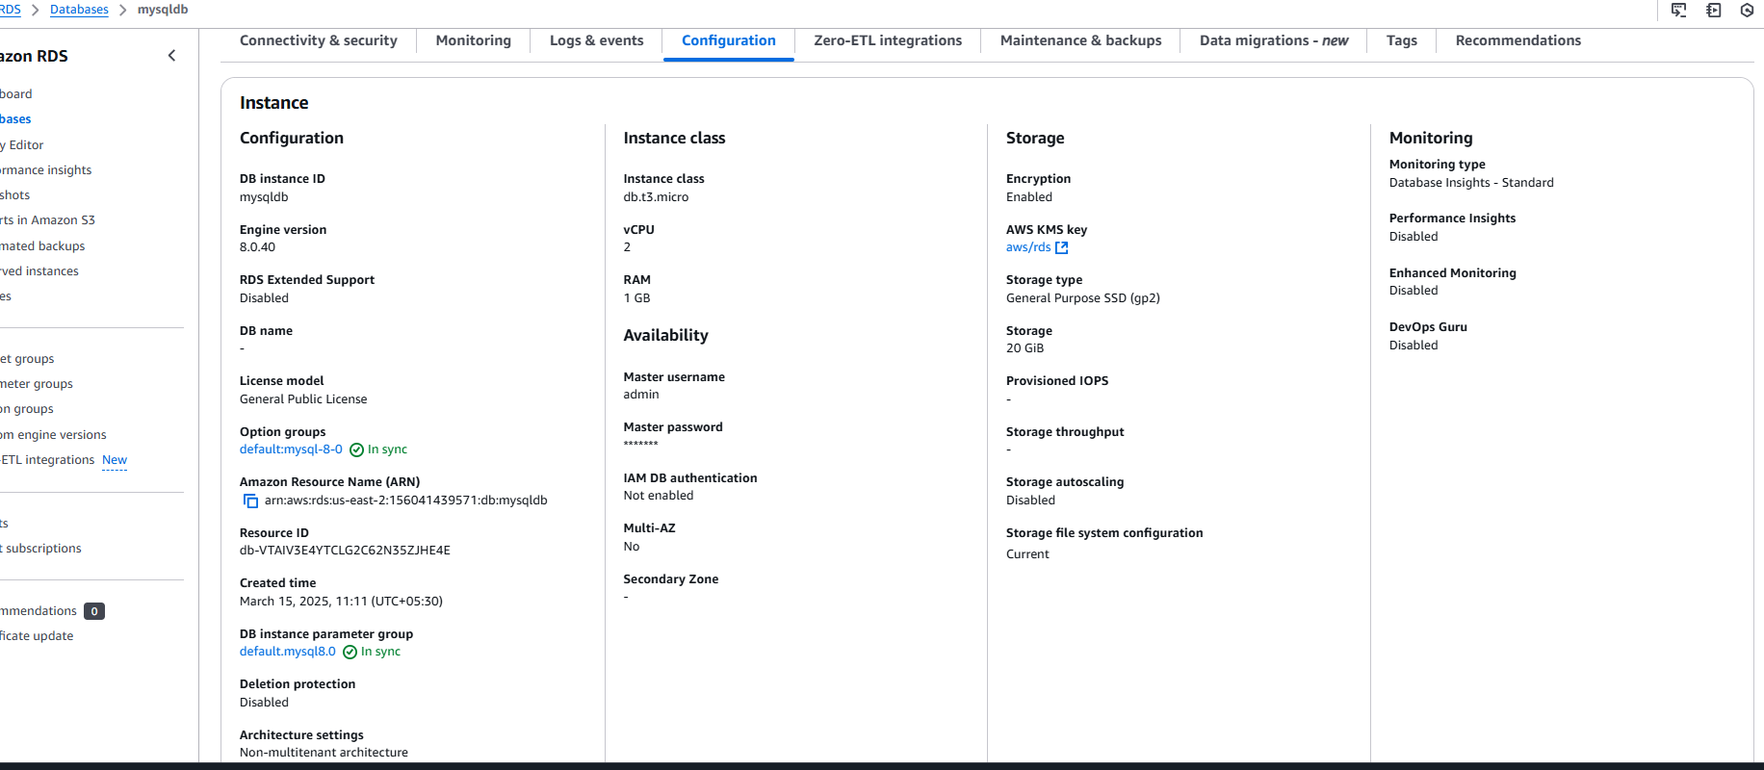
9) Take Backup of db and restore the DB

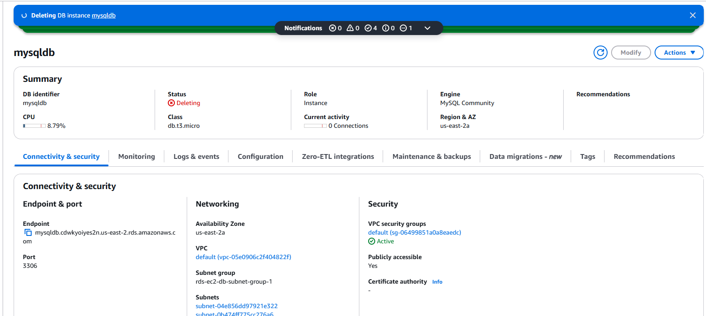
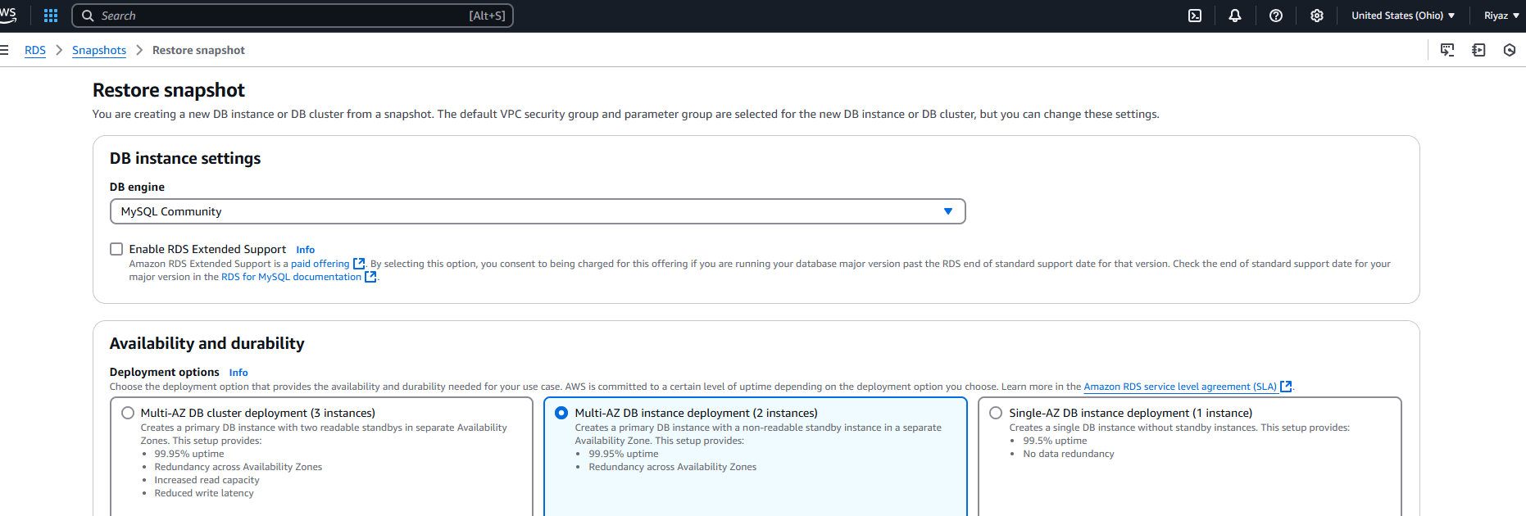
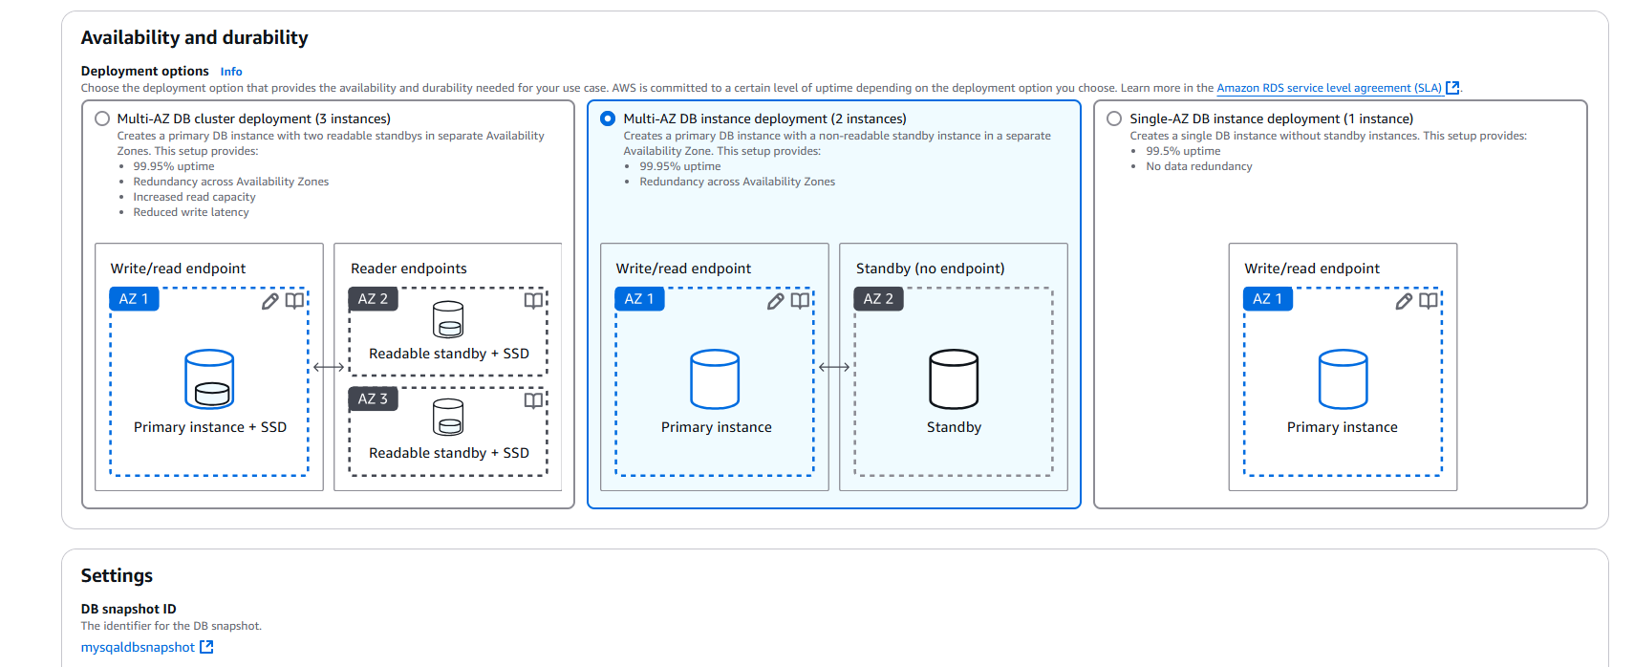
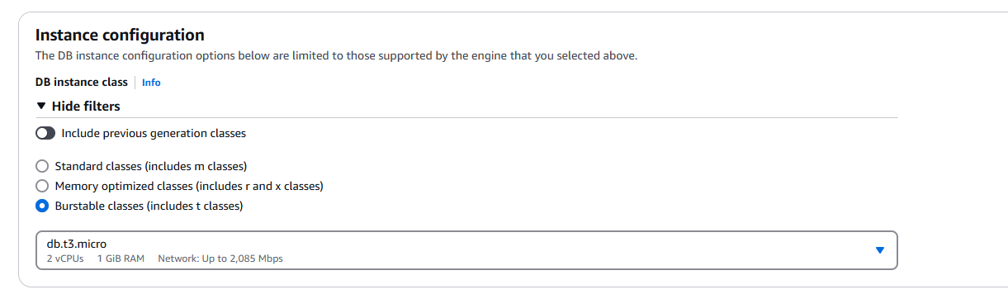
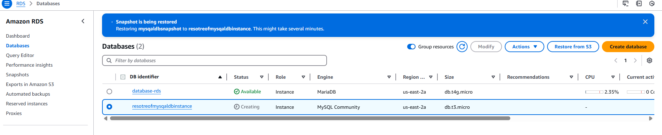

Same options – click on restore db instance

10) Create ReadReplca

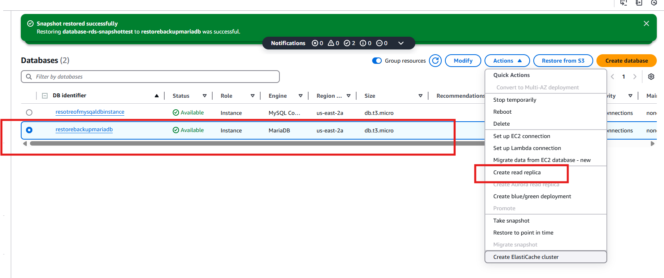
Click on create read repica

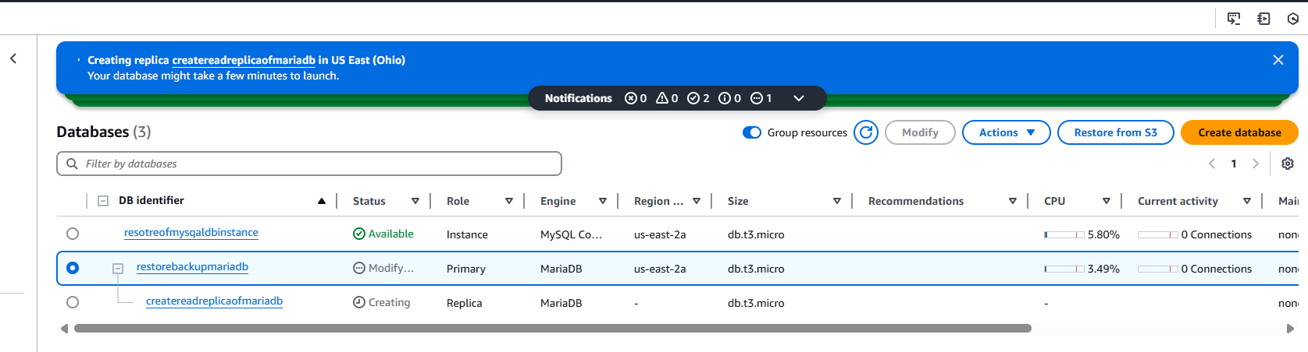

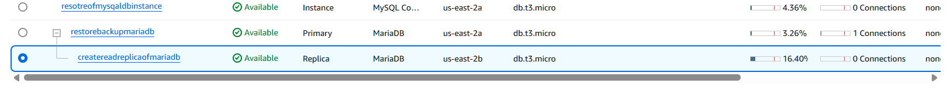
Then we will get replica of rds instance with another endpoint name:
Connect to replica:
mysql -h mysqldb2.cmzy2umkwl5h.us-east-1.rds.amazonaws.com -P 3306 -u admin –p

this is replication to connect server
connect the server
'''mysql -h createreadreplicaofmariadb.cdwkyoiyes2n.us-east-2.rds.amazonaws.com -u adminkazmi –p

mysql> SHOW DATABASES;
+--------------------+
| Database |
+--------------------+
| ec2db |
| information_schema |
| innodb |
| kazmidb |
| mysql |
| performance_schema |
| sys |
+--------------------+
7 rows in set (0.01 sec)

mysql>
mysql> SELECT * FROM table1;

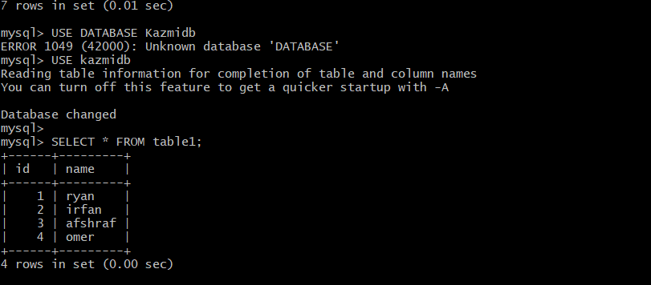

mysql> SHOW VARIABLES LIKE 'read_only';

